**Sprint 2**

**Agile Board - Work View captured in JIRA**

**Example 1 of 3**

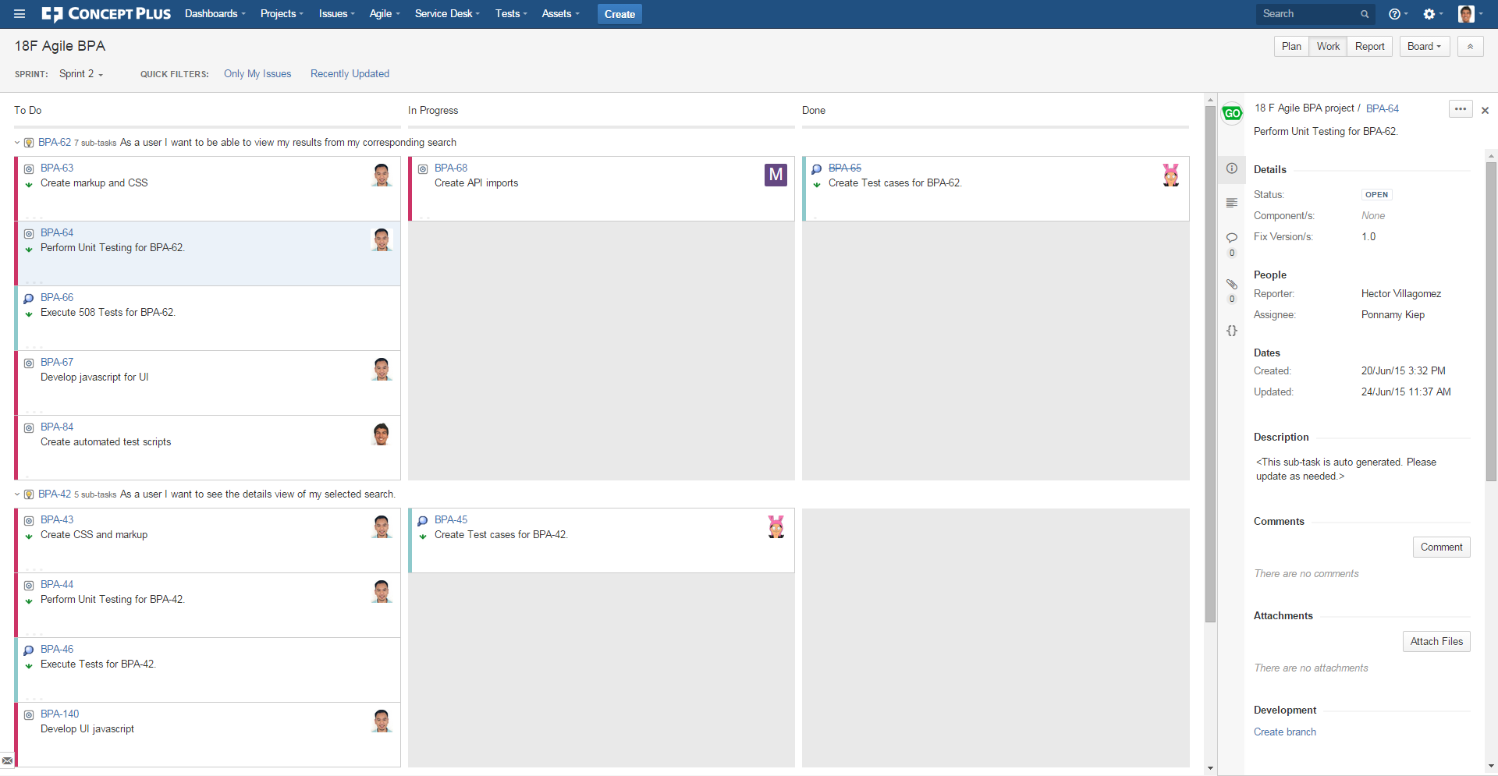

**Example 2 of 3**

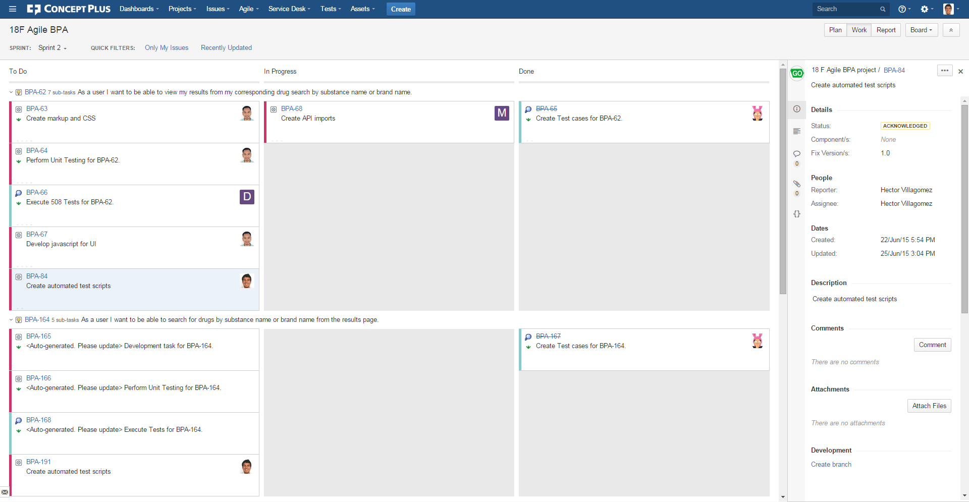

**Example 3 of 3**

